Lecture 2

CPSC 131  
12/7/2020

1. Graphs
   1. Adjacency List  
      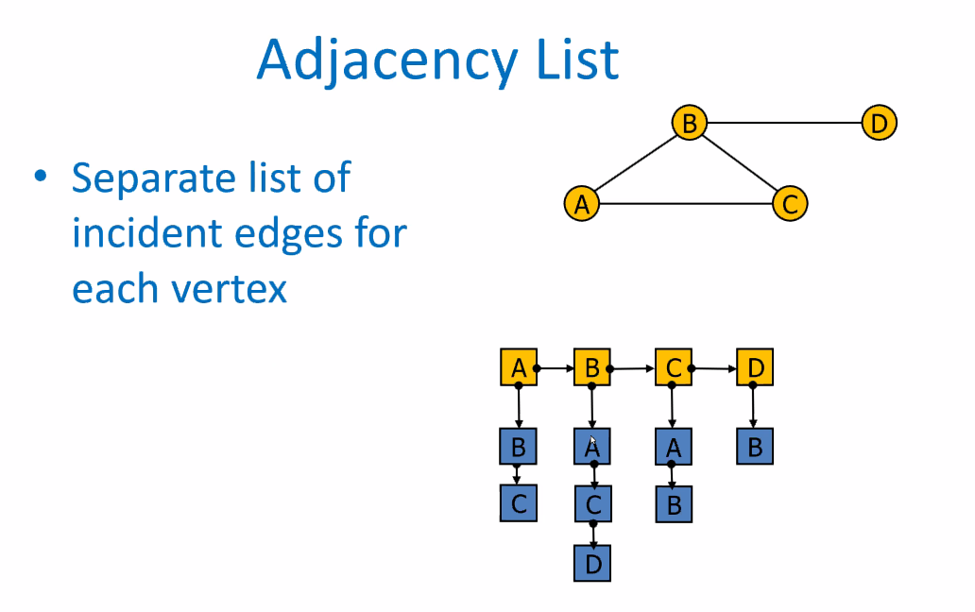
      1. Represent this by a list of lists
   2. Adjacency Matrix  
      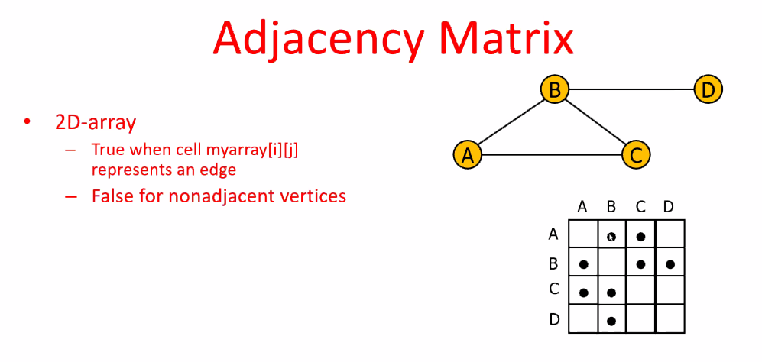
   3. Comparative performance  
      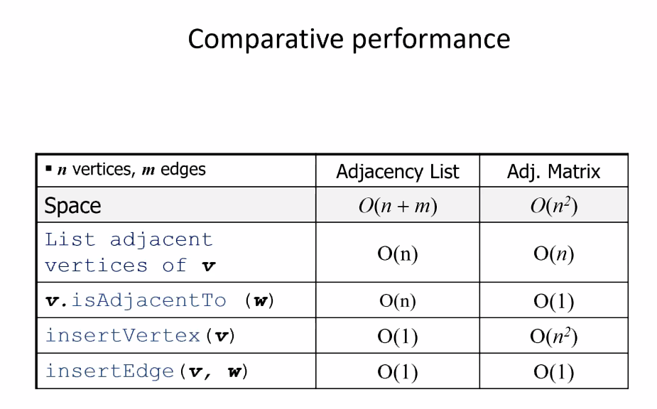
      1. For an adjacent list, it’s O(n). For an adjacent matrix, it’s O(log n).
      2. A list answers if you want to know if two nodes are adjacent to another, you can check the Adjacency matrix.
      3. As noted, there are times when the matrix outperforms the list.
   4. Example: Critical Path Planning  
      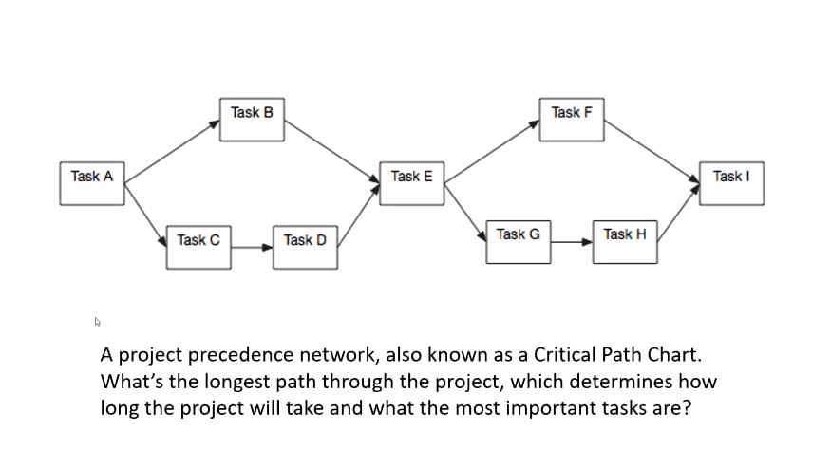
      1. Some tasks cannot start until thing before it gets done
      2. It’s an example of graphs being used in software development.
   5. Graph Traversals
      1. Depth-First Traversal  
         